Plant Portrait Nature’s Green

Wicks from Nature's Green
Wicks have long been a successful method for extending watering cycles in commercial environments. By applying wick technology to a tilted grow pot, watering cycles of 10 days to 3 weeks or more can be achieved.
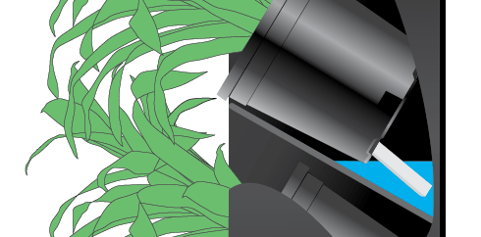

Simply add the specified amount of water to each tray and allow the wicks to draw water into the grow pots. Nature's Green has sturdy Caponic wicks in stock at all times.de with environmentally- friendly and durable Eco- Synthetic resin.
