Rise  Rise Post-Consumer made from products that have already had a useful life.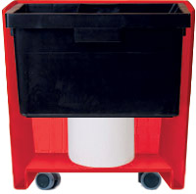 |  | Hidden Casters  Special castor platform available with 5 hidden wheels.  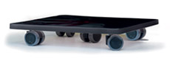  Rise Inside  All liners are equiped with a robust centered column. Sub-irrigation system available. |  | 